Healthy Choices Restaurant Partnership

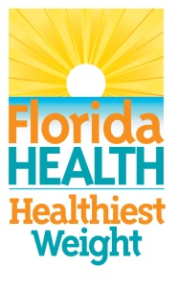

Currently over 60% of Franklin County adults and nearly 40% of adolescents are considered obese or overweight. Overweight and obesity are major risk factors for many of the leading causes of death and disease in the U.S. including heart disease, stroke, type 2 diabetes, high blood pressure, and certain types of cancer. There are many factors that contribute to the obesity epidemic. The number of meals eaten outside the home is one of those factors.
To help combat these growing numbers, the Department of Health in Franklin County has initiated a new program designed to help diners make smarter, more informed decisions about their nutritional health. The Healthy Choices Restaurant (HCR) Program is a countywide collaborative effort, made possible by teaming up with our local restaurant partners to identify existing healthy menu fare and highlighting their various nutritional profiles. Together we will spotlight those Partner Restaurants and help promote their selected healthy menu items.
If you are a restaurant owner who is interested in spotlighting your healthy menu fare, we invite you to partner with us! Let us help you get the word out about healthier choices in your establishment
For more information call David Walker at 850-653-2111 ext. 119.

